

Statewide (US Senate Republican Primary) Poll Results

POLLING METHODOLOGY
- Likely Republican primary voters in Louisiana, conducted October 15-17, 2025 (4.0% MOE with 95% confidence interval)
- Sample size: 610 (67% cell phones (texted), 33% landlines/cells (live dialed) - “hybrid” poll)
- Race/party: 93% white, 4% black, 3% “Other”/70% Republican, 30% Unaffiliateds
- Gender: 52% female, 48% male
- Geography (Nielsen media market): Alexandria 6%, Baton Rouge 21%, Lafayette 15%, Lake Charles 6%, Monroe 9%, New Orleans 33%, Shreveport 10% (Explanation is graphically depicted in Exhibit A).
- Note: Since the previous poll, the Independent Party has been dissolved, and its members are now “no party” voters

SUMMARY

In the crowded upcoming US Senate race, the primary is now only six months away. Incumbent Sen. Bill Cassidy has led the field among all announced and expected Republican candidates in multiple polls with Treasurer John Fleming consistently coming in a close second but winning 36-29 in the projected runoff with Cassidy.

Senator Cassidy’s lead has disappeared in a new poll conducted October 15-17 by JMC Analytics and Polling. John Fleming now leads all announced and expected candidates (including Bill Cassidy) with Fleming at 25% and Cassidy at 23% (the COMBINED total of the remaining ballot tested candidates was 17%). In a head-to-head matchup against Sen. Cassidy, Dr. Fleming has now stretched his lead over Cassidy by another 4 points, going from 36-29% to 40-29% (31% are undecided). Fleming's growing lead over Cassidy has continued despite millions of advertising dollars spent on TV, radio, and billboards by Cassidy's campaign, with an assist from special interest groups from Washington. In fact, compared to the previous poll, Fleming is the only candidate showing any momentum in the polls.

While other candidates boast of the amount of money they are raising from special interests (most of which is from outside of Louisiana), Treasurer John Fleming has built a dynamic grassroots campaign with over 200 volunteers and over 10,000 signs placed in communities throughout the state. This clearly establishes him as a candidate of the people in the 2026 US Senate race in Louisiana.

John Fleming is an appealing candidate for several other important reasons. Having grown up in a working-class home, John learned very early in life how to overcome adversity with his father dying while John was still in high school, as well as a disabled mother and two younger siblings. He found a way to finance his college and medical school education by working odd jobs. He went on to graduate from medical school, completed his training in family medicine before serving his country for six years as a US Navy Medical Officer. After military service, John started a medical practice in Minden, La. A few years later he started several businesses employing over 350 Louisianans. His businesses and medical practice continue to operate today.

In 2008 John was elected to the US House of Representatives serving the 4th district of Louisiana. During his eight-year service, he was a co-founder of the House Freedom Caucus, passed a federal pro-second amendment law, achieved an A+ score supporting anti-illegal immigration legislation, and attained a lifetime 97% conservative voting record. John joined the first Trump administration in 2017 where he was appointed Deputy Assistant Secretary of Health and Human services. Later Trump appointed him as Assistant Secretary of Commerce for Economic Development, then President Trump detailed him to the position of Deputy Chief of Staff in the White House 2020-21.

Treasurer Fleming's credentials as the strongest MAGA conservative, combined with a lifetime record of servant leadership to the people of Louisiana, makes him the most qualified candidate to represent Louisiana as a US Senator.

Appendix A: Louisiana regions
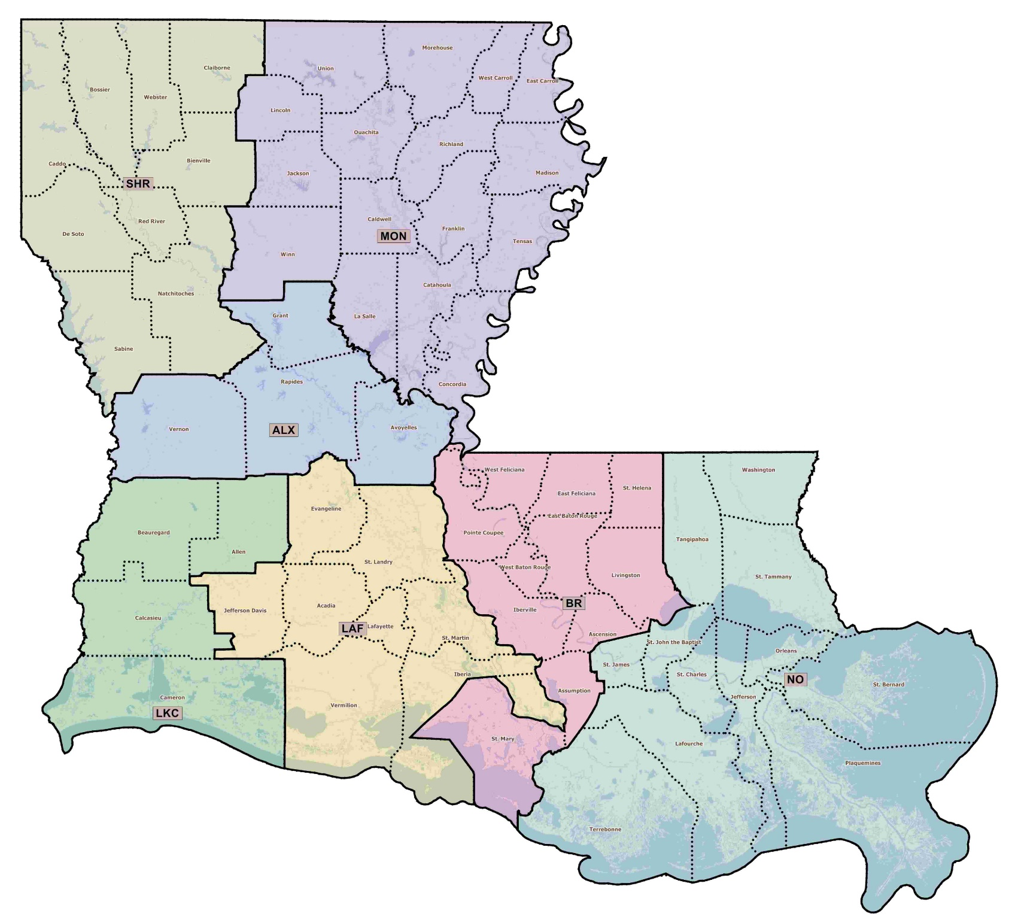
(ALX=Alexandria, BR=Baton Rouge, LAF=Lafayette, LKC=Lake Charles, MON=Monroe, NO=New Orleans, SHR=Shreveport)

